**Cyber bullying in online games（如何应对网络游戏的霸凌）**

Question 8 (Sub-question 5):Automatically identify and block illegal words (overall evaluation, 1 point is very bad) [Matrix question]

|  |  |  |  |  |  |  |  |  |
| --- | --- | --- | --- | --- | --- | --- | --- | --- |
| X\Y | don't know unknown | very worse | poor worse | normal | better nice | very nice very nice | Subtotal | The average score |
| primary school | 5 (41.67%) | 1 (8.33%) | 1 (8.33%) | 2 (16.67%) | 0 (0.00%) | 3 (25%) | 12 | 3.43 |
| Middle school | 6 (18.18%) | 4 (12.12%) | 3 (9.09%) | 10 (30.30%) | 8 (24.24%) | 2 (6.06%) | 33 | 3.04 |
| Undergraduate (Undergraduate) | 10 (11.49%) | 8 (9.20%) | 18 (20.69%) | 29 (33.33%) | 17 (19.54%) | 5 (5.75%) | 87 | 2.91 |
| master | 5 (8.77%) | 5 (8.77%) | 15 (26.32%) | 14 (24.56%) | 14 (24.56%) | 4 (7.02%) | 57 | 2.94 |
| Doctor | 2 (16.67%) | 1 (8.33%) | 1 (8.33%) | 2 (16.67%) | 6 (50%) | 0 (0.00%) | 12 | 3.3 |

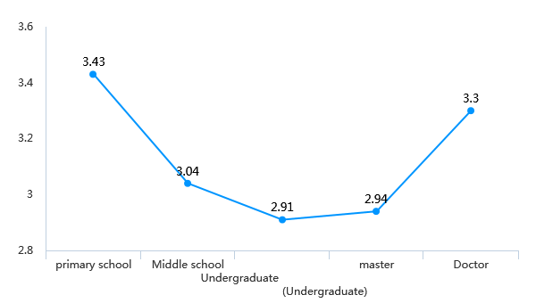

Question 10 (Sub-question 5):Report to the operator (overall evaluation, 1 point is very bad) [Matrix question]

|  |  |  |  |  |  |  |  |  |
| --- | --- | --- | --- | --- | --- | --- | --- | --- |
| X\Y | don't know unknow | very worse | poor worse | normal | better nice | very nice very nice | Subtotal | The average score |
| primary school | 3 (25%) | 1 (8.33%) | 2 (16.67%) | 1 (8.33%) | 2 (16.67%) | 3 (25%) | 12 | 3.44 |
| Middle school | 7 (21.21%) | 1 (3.03%) | 5 (15.15%) | 8 (24.24%) | 10 (30.30%) | 2 (6.06%) | 33 | 3.27 |
| Undergraduate (Undergraduate) | 12 (13.79%) | 9 (10.34%) | 18 (20.69%) | 22 (25.29%) | 23 (26.44%) | 3 (3.45%) | 87 | 2.91 |
| master | 4 (7.02%) | 7 (12.28%) | 12 (21.05%) | 12 (21.05%) | 16 (28.07%) | 6 (10.53%) | 57 | 3.04 |
| Doctor | 1 (8.33%) | 0 (0.00%) | 1 (8.33%) | 3 (25%) | 6 (50%) | 1 (8.33%) | 12 | 3.64 |

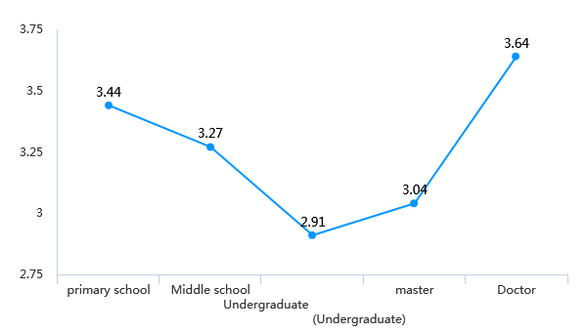

Question 12 (Sub-question 5):Player education, through creating a good game community atmosphere, allowing players to consciously maintain the game environment (overall evaluation, 1 point is very bad) )) [Matrix question]

|  |  |  |  |  |  |  |  |  |
| --- | --- | --- | --- | --- | --- | --- | --- | --- |
| X\Y | don't know unknow | very worse | poor worse | normal | better nice | very nice very nice | Subtotal | The average score |
| primary school | 7 (58.33%) | 0 (0.00%) | 1 (8.33%) | 3 (25%) | 0 (0.00%) | 1 (8.33%) | 12 | 3.2 |
| Middle school | 7 (21.21%) | 2 (6.06%) | 1 (3.03%) | 11 (33.33%) | 9 (27.27%) | 3 (9.09%) | 33 | 3.38 |
| Undergraduate (Undergraduate) | 14 (16.09%) | 16 (18.39%) | 14 (16.09%) | 25 (28.74%) | 12 (13.79%) | 6 (6.90%) | 87 | 2.70 |
| master | 6 (10.53%) | 8 (14.04%) | 16 (28.07%) | 12 (21.05%) | 10 (17.54%) | 5 (8.77%) | 57 | 2.76 |
| Doctor | 3 (25%) | 0 (0.00%) | 0 (0.00%) | 3 (25%) | 6 (50%) | 0 (0.00%) | 12 | 3.67 |

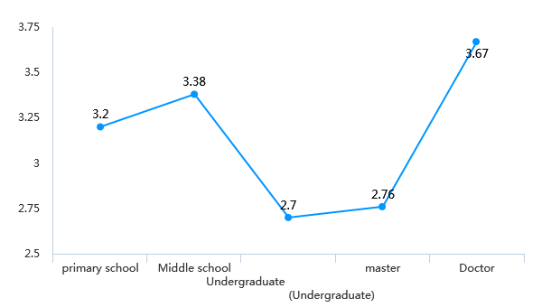

Question 14 (Sub-question 5):automated disciplinary system and player reform system in League of Legends (overall evaluation, 1 point is very bad) [Matrix question]

|  |  |  |  |  |  |  |  |  |
| --- | --- | --- | --- | --- | --- | --- | --- | --- |
| X\Y | don't know unknow | very worse | poor worse | normal | better nice | very nice very nice | Subtotal | The average score |
| primary school | 2 (50%) | 0 (0.00%) | 0 (0.00%) | 1 (25%) | 0 (0.00%) | 1 (25%) | 4 | 4 |
| Middle school | 3 (18.75%) | 2 (12.5%) | 0 (0.00%) | 6 (37.5%) | 3 (18.75%) | 2 (12.5%) | 16 | 3.23 |
| Undergraduate (Undergraduate) | 7 (14.29%) | 5 (10.20%) | 11 (22.45%) | 14 (28.57%) | 8 (16.33%) | 4 (8.16%) | 49 | 2.88 |
| master | 4 (12.90%) | 0 (0.00%) | 7 (22.58%) | 7 (22.58%) | 9 (29.03%) | 4 (12.90%) | 31 | 3.37 |
| Doctor | 0 (0.00%) | 0 (0.00%) | 1 (20%) | 1 (20%) | 1 (20%) | 2 (40%) | 5 | 3.8 |

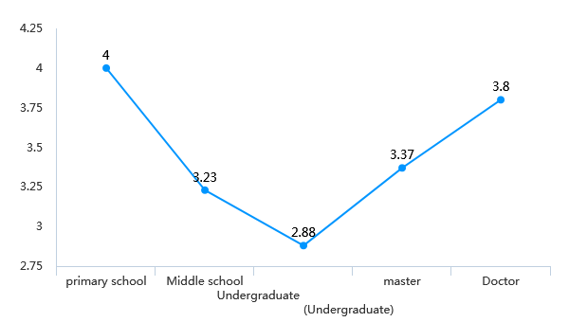

Question 16 (Sub-question 5):Block user, delete post and/or flag content when toxic behavior is occurring (overall evaluation, 1 point is very bad) [Matrix question]

|  |  |  |  |  |  |  |  |  |
| --- | --- | --- | --- | --- | --- | --- | --- | --- |
| X\Y | don't know unknow | very worse | poor worse | normal | better nice | very nice very nice | Subtotal | The average score |
| primary school | 5 (41.67%) | 0 (0.00%) | 0 (0.00%) | 3 (25%) | 1 (8.33%) | 3 (25%) | 12 | 4 |
| Middle school | 7 (21.21%) | 2 (6.06%) | 3 (9.09%) | 13 (39.39%) | 7 (21.21%) | 1 (3.03%) | 33 | 3.08 |
| Undergraduate (Undergraduate) | 17 (19.54%) | 5 (5.75%) | 12 (13.79%) | 28 (32.18%) | 19 (21.84%) | 6 (6.90%) | 87 | 3.13 |
| master | 5 (8.77%) | 5 (8.77%) | 8 (14.04%) | 19 (33.33%) | 18 (31.58%) | 2 (3.51%) | 57 | 3.08 |
| Doctor | 2 (16.67%) | 0 (0.00%) | 1 (8.33%) | 1 (8.33%) | 6 (50%) | 2 (16.67%) | 12 | 3.9 |

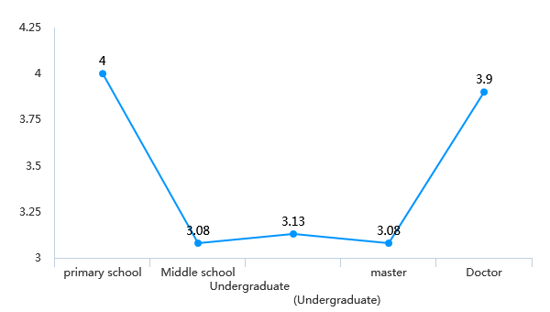

Question 18 (Sub-question 5):In-game rewards to encourage prosocial behavior in the gaming community (overall evaluation, 1 point is very bad) [Matrix question]

|  |  |  |  |  |  |  |  |  |
| --- | --- | --- | --- | --- | --- | --- | --- | --- |
| X\Y | don't know unknow | very worse | poor worse | normal | better nice | very nice very nice | Subtotal | The average score |
| primary school | 6 (50%) | 0 (0.00%) | 0 (0.00%) | 1 (8.33%) | 2 (16.67%) | 3 (25%) | 12 | 2.17 |
| Middle school | 7 (21.21%) | 3 (9.09%) | 4 (12.12%) | 3 (9.09%) | 11 (33.33%) | 5 (15.15%) | 33 | 2.70 |
| Undergraduate (Undergraduate) | 12 (13.79%) | 9 (10.34%) | 9 (10.34%) | 27 (31.03%) | 24 (27.59%) | 6 (6.90%) | 87 | 2.69 |
| master | 6 (10.53%) | 1 (1.75%) | 8 (14.04%) | 12 (21.05%) | 20 (35.09%) | 10 (17.54%) | 57 | 3.21 |
| Doctor | 1 (8.33%) | 1 (8.33%) | 2 (16.67%) | 1 (8.33%) | 6 (50%) | 1 (8.33%) | 12 | 3.08 |

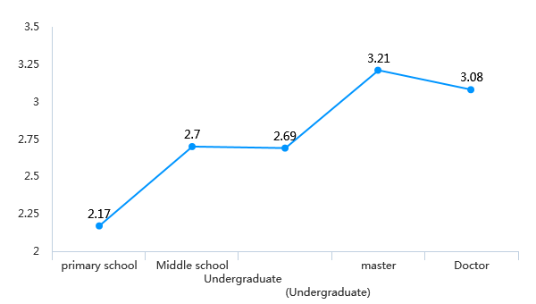

Question 20 (Sub-question 5):Temporary or permanent ban and/or forced withdrawal from game if found at fault (overall evaluation, 1 point is very bad) [Matrix question]

|  |  |  |  |  |  |  |  |  |
| --- | --- | --- | --- | --- | --- | --- | --- | --- |
| X\Y | don't know unknow | very worse | poor worse | normal | better nice | very nice very nice | Subtotal | The average score |
| primary school | 6 (50%) | 0 (0.00%) | 0 (0.00%) | 2 (16.67%) | 2 (16.67%) | 2 (16.67%) | 12 | 2 |
| Middle school | 7 (21.21%) | 1 (3.03%) | 1 (3.03%) | 7 (21.21%) | 10 (30.30%) | 7 (21.21%) | 33 | 3 |
| Undergraduate (Undergraduate) | 11 (12.64%) | 6 (6.90%) | 8 (9.20%) | 31 (35.63%) | 18 (20.69%) | 13 (14.94%) | 87 | 2.90 |
| master | 4 (7.02%) | 3 (5.26%) | 5 (8.77%) | 19 (33.33%) | 17 (29.82%) | 9 (15.79%) | 57 | 3.21 |
| Doctor | 1 (8.33%) | 0 (0.00%) | 2 (16.67%) | 4 (33.33%) | 4 (33.33%) | 1 (8.33%) | 12 | 3.08 |

